Bodyweight Pilates

Clickbank Hoplink: http://CBID.bwpilates.hop.clickbank.net?id=text

Replace XXX with your Clickbank Id

Below are samples of emails I’ve used for promoting the program to my list.

EMAIL #1
Image: http://www.bodyweightpilates.com/wp-content/uploads/2015/10/BVtestimonial.png
SL: How she lost 5 inches off her Waistline [pic]

I was so impressed to see this!
Here's a picture I want to share of a woman named Brigette Vargas and why I'm so impressed is because she lost over 5 inches off her waistline in a matter of days!
What's even more impressive is that she shrunk her belly pooch and now has Visible Abs definition!
Check it out for yourself....

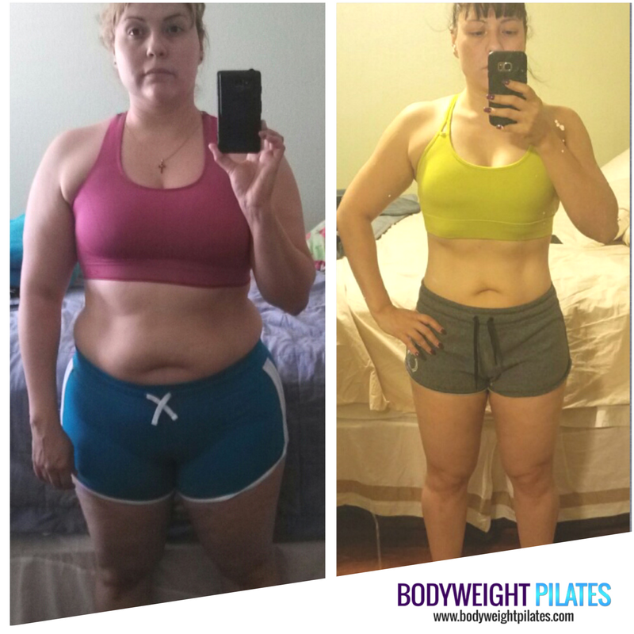

Pretty Amazing, right?

And get this, she didn’t do any crazy dieting or hours of cardio. So, if you want to get results like this, then you have to see what Brigette did to get Visible Abs and feel confident in her body.

==> Shrink Your Belly Pooch!

Sylvia =)

EMAIL #2
Pilates Flexibility graphic:
http://www.bodyweightpilates.com/wp-content/uploads/2016/12/cover-flexibility-3d-sm.png
Subject Line: Increase your flexibility with this…
How flexible are you?

Over time we lose flexibility, it just happens.

Especially if we don’t take preventive measures, stiff…tight muscles develop.

Instead of being active all day long we spend most of our time in front of a computer, commuting or being sedentary the majority of the day.

Being inflexible, and stiff can cause some serious injuries when least expected.

One of the main reasons why I started with Pilates almost 15 years ago was because of the pain and injuries from major car accidents, to slipped discs, shoulder injury to knee problems.

When I get asked how do I stay active...my reply is simple!

“Pilates! It keeps my body in proper alignment, flexible, agile and keeps my muscles equally balanced to prevent any unneeded strain on my joints and body. Plus ...I have a flat tummy now that I'm 43 years old but feel 10 years younger!”

There’s no magic pill or move that will miraculously make you super flexible the next morning. Lasting results come from working on it every day.

But the good news is you don't have to spend a lot of time every day working on your flexibility.

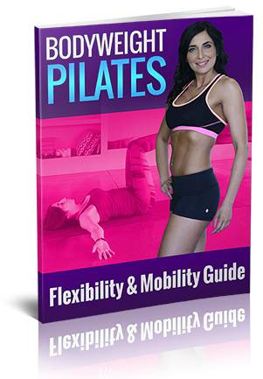
That's why I've included the Pilates Flexibility and Mobility Guide as a FREE bonus in the Bodyweight Pilates program.

With my brand NEW Bodyweight Pilates program, you’ll spend only 10 minutes a day to reduce your tight stiff muscles and flatten your tummy at the same time!

Instantly feel a HUGE difference in your range of motion and flexibility.

Join me and thousands of others who are loving the Bodyweight Pilates system...click the link below:

==> Look & feel 10 Years Younger with the Bodyweight Pilates Methods
I hope you take a minute and grab a copy for yourself, Your body will love you for it!

Sylvia

PS. In the Pilates Flexibility Guide you'll get daily movements that'll help you stay agile and flatten your tummy at the same time. Just Click Over Here,

EMAIL #3
Image: http://www.360pilatesworkout.com/wp-content/uploads/2016/07/File-Jul-09-10-57-08-AM.jpeg
SUBJECT LINE: Instant Tummy Tuck
Have you ever felt that no matter how may crunches you do….You just can’t seem to get your abs as tight as you want them?

Sure your abs will feel sore but you still feel flabby and loose.

That’s what you would find with practically every ab workout out there.

Until now!

Today I'm sharing my proven technique to Tighten Your Tummy that’ll give you an Instant Tummy Tuck without the surgery…

...Pretty cool, Right?!

In fact, here's one of my Superstar Clients who used the exact technique to Tighten her Tummy!
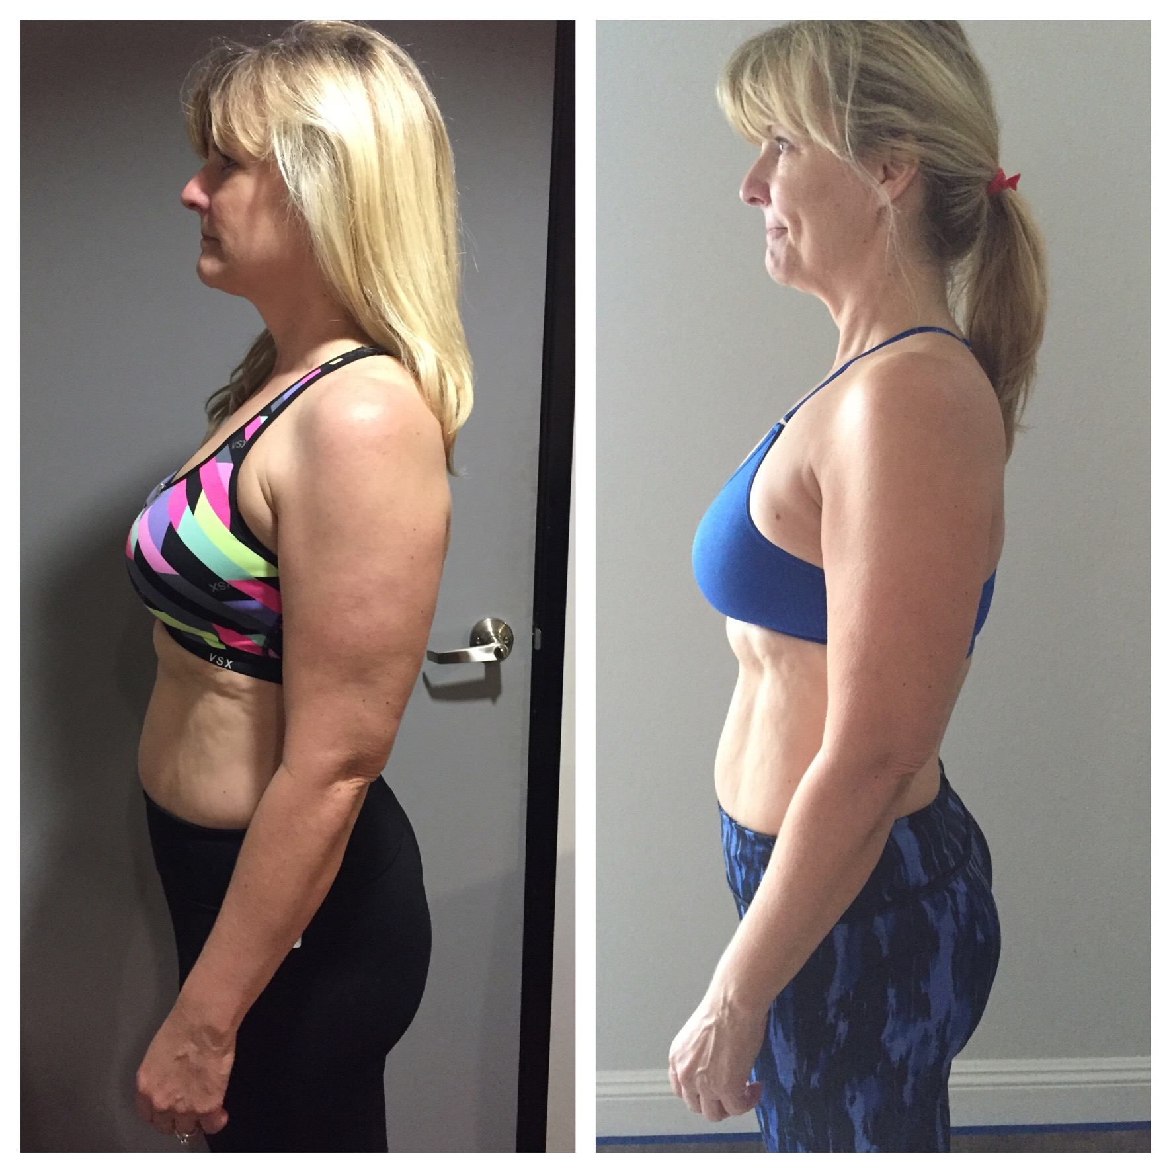

PLUS…you’ll see and feel your waistline shrinking and everything tighten up.

Instantly Tighten Your Tummy, go here to get my technique.

Talk Soon!
Sylvia

PS. Get A Tight Tummy WITHOUT Doing Cardio! How cool is that! Click here to find out how.

Pilates Swipe for Fatloss List
Subject Line: #1 Method to losing stubborn belly fat
Celebrities and fitness pros from around the world agree it’s the hottest method for TRULY defining abs and losing those unwanted pounds.
It’s a MUST to add these to your workouts
You see, my friend and Pilates Expert Sylvia Favela crafted a Pilates system designed to not only flatten your tummy and tighten your body but to KEEP it that way.
It helped her lose the baby fat, you know that stubborn mommy pooch after having her son and rid herself of that annoying muffin top.
This #1 method to lose stubborn belly fat and tone your body has been the go to method for today’s hottest celebrities.
When your body refuses to lose that last little bit of lower belly fat and you’re feeling frustrated staring at the muffin top in the mirror.
This Pilates system can finally rid your body of the extra weight you’re carrying around and awaken your fatigued out of shape physique.
Take a sneak peek of the #1 method to lose stubborn belly fat and tone your body. (INSERT AFFILIATE LINK)
Please share this with anyone who is struggling with losing stubborn belly fat.
[SIGN OFF]
P.S. You should NOT avoid this cutting edge Pilates method.....even if you're scared of trying it like most are because of the challenge it brings…
Do NOT avoid this hot new Pilates method
(INSERT AFFILIATE LINK)

