Bodyweight Pilates
Top Converting Swipes

Hoplink: http://CBID.bwpilates.hop.clickbank.net?id=text

Replace CBID with your Clickbank id

EMAIL 1
(Highest CTR, Proven & tested email by Shawna K (My Bikini Belly)
Subject Line: Pee your pants? [solution]

Have you experienced a sneezing or laughing attack and then come to realize you’ve pee’d your pants?

Most people think this is just part of getting older…It’s one of those touchy intimate subjects that many may complain about and no one thinks there's a solution.

But there actually is something you CAN do about it.

The reason you have leakage when you laugh or sneeze is because you have a weak pelvic floor.

Luckily those muscles can be strengthened like any other.

You can use this exercise to work the core from the inside out.

This exercise will strengthen what's called the corset muscles or pelvic girdle.

You'll experience:
- less back pain and stiffness
- a heightened sex life
- improved posture
- feeling slimmer
- more confidence
Remember the good old days when you laughed so hard your belly hurt?

Well now you can enjoy side splitting laughter without peeing your pants. All while getting the added benefit of shrinking your waistline.

See for yourself in this special article below from my friend Sylvia…

==> STOP peeing your pants
[SIGN OFF]

PS. This form of exercise is NOT just for women.

Men experience pelvic floor weakness too. In addition, men tend to be less flexible and so this exercise improves range of motion resulting in performance improvement in things like golf and other sports.

EMAIL 2
(Proven & Tested email by Tyler Bramlett, thank you for sharing )

Image Link:
http://www.360pilatesworkout.com/wp-content/uploads/2014/06/s52014.png
Subject Line: Guess how old she is? [SWEET PIC]

I wanted to share with you a type of exercise that most people swap under the rug as weak or for women only.

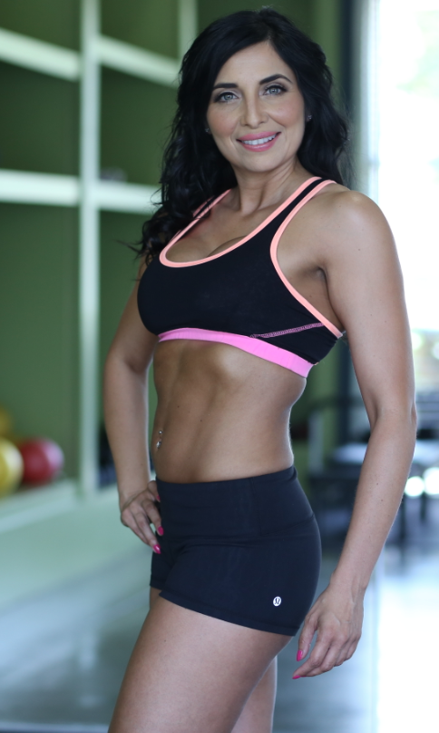
In FACT, you might be just like me a few years ago, thinking that this type of exercise was completely useless. But you’d be WRONG!
At one point I may have even said it was in the same category as Zumba (nothing against dance, just be sure to do some strength and skill work as well).
So, what changed my mind?
This chick ---------------------------------------------------->

GUESS HOW OLD SHE IS???
NOPE, not 30 like you thought...

...she’s 42 years young!

She Looks Good, Right?
She credits her youthful appearance and obviously slim core to this...
=> Learn Sylvia SECRET To Her Youthful Appearance And Slender Waist...

[SIGN OFF]

EMAIL 3
(Proven & tested email by Adam Steer, thank you for sharing )

Subject Line: Best “abs” workout ever…

Trendy exercises come and go every year and I thought it was the same for this particular exercise method.

And…I used to think this “workout” was for grannies.

But I was so wrong!

After a little convincing, I gave it a try. And I was amazed at how tough it was. In fact, my abs were crazy-sore for at least 2 days…

What’s this deceptively challenging workout method?

Check it out here <--- Harder than it looks

WARNING: When you visit that page, you might be tempted to immediately click away. Don't. Once you start reading, you're going to want to try this. (...at LEAST once...)

[SIGN OFF]

